


Database Management Assignment File (ENCS205)
Bachelor of Technology in
Computer Science and Engineering

Submitted by
Harsh (2401010096)
B. Tech CSE (Core) – 4th Semester Section: A

Submitted To:
MS. Mansi Kajal

School of Engineering & Technology
K. R. MANGALAM UNIVERSITY
Sohna, Haryana 122103, India Jan-2026

- Consider following databases and draw ER diagram and convert entities
and relationships to relation table for a given scenario:
COLLEGE DATABASE:
STUDENT (USN, SName, Address, Phone, Gender)
SEMSEC (SSID, Sem, Sec)
CLASS (USN, SSID)
SUBJECT (Subcode, Title, Sem, Credits)
IAMARKS (USN, Subcode, SSID, Test1, Test2, Test3, FinalIA)

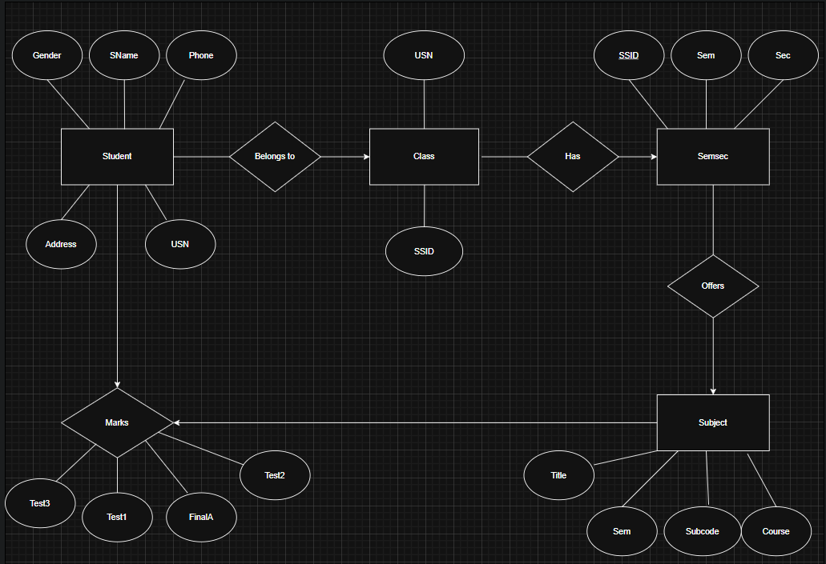

ER diagram for a College Database to represent how different academic data is organized and related.
STUDENT entity stores student details like USN, name, address, phone, and gender.
SEMSEC entity represents semester and section information using SSID.
CLASS is a relationship that connects STUDENT and SEMSEC, showing which student belongs to which semester and section.
SUBJECT entity stores subject details such as subject code, title, semester, and credits.
IAMARKS entity records internal assessment marks of students for each subject, including Test1, Test2, Test3, and Final IA marks. It connects STUDENT, SUBJECT, and SEMSEC using keys like USN, Subcode, and SSID.

2. Consider following databases and draw ER diagram and convert entities
and relationships to relation table for a given scenario:

COMPANY DATABASE:
EMPLOYEE (SSN, Name, Address, Sex, Salary, SuperSSN, DNo)
DEPARTMENT (DNo, DName, MgrSSN, MgrStartDate)
DLOCATION (DNo,DLoc)
PROJECT (PNo, PName, PLocation, DNo)
WORKS_ON (SSN, PNo, Hours)

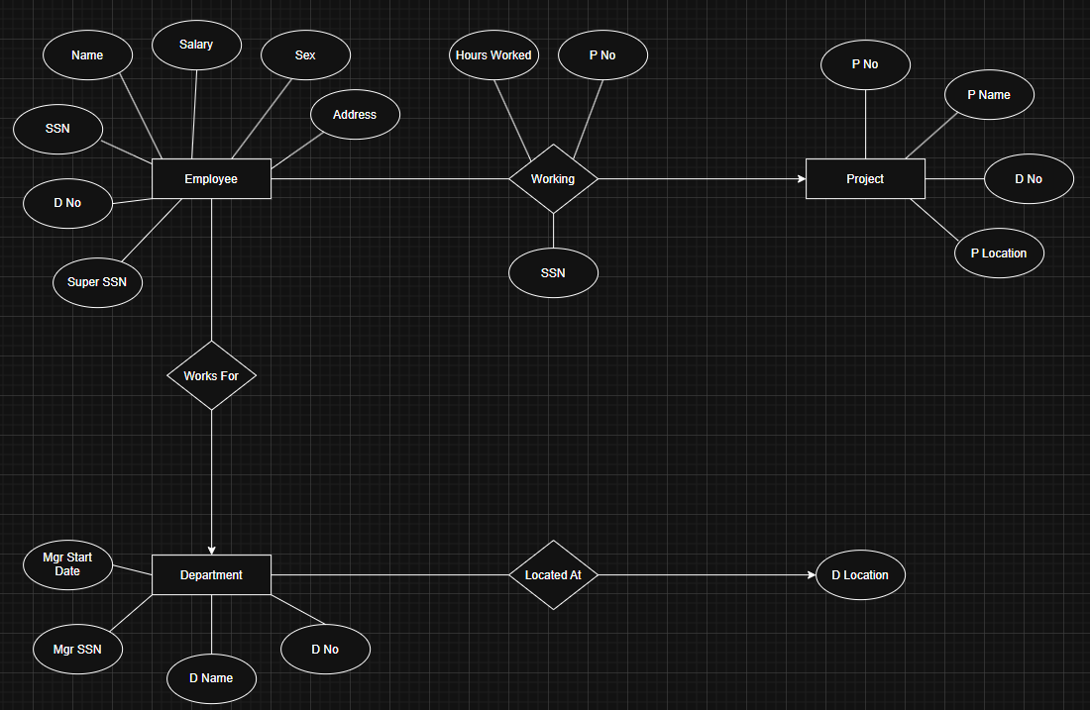

ER diagram for a Company Database to represent employees, departments, projects, and their relationships.
EMPLOYEE entity stores employee details such as SSN, name, address, sex, salary, supervisor SSN, and department number.
DEPARTMENT entity contains department information like department number, department name, manager SSN, and manager start date.
DLOCATION entity represents the different locations of each department.
PROJECT entity stores project details such as project number, project name, project location, and department number.
WORKS_ON is a relationship between EMPLOYEE and PROJECT that records how many hours an employee works on a project.
The ER diagram also shows relationships like employee supervision, employees working for departments, and departments controlling project.

3.Database Schema for a customer-sale scenario
Customer (Cust id: integer, cust_name: string)
Item (item_id: integer, item_name: string, price: integer)
Sale (bill_no:integer,bill_data:date,cust_id: integer, item_id: integer, qty_sold: integer) For the above schema, perform the following—
- Create the tables with the appropriate integrity constraints.
- Insert around 10 records in each of the tables.
- List all the bills for the current date with the customer names and item numbers.
- List the total Bill details with the quantity sold, price of the item and the final amount.
- List the details of the customer who have bought a product which has a price>200.
- Give a count of how many products have been bought by each customer
- Give a list of products bought by a customer having cust_id as 5.
- List the item details which are sold as of today.
- Create a view which lists out the bill_no, bill_date, cust_id, item_id, price, qty_sold, amount.
- Create a view which lists the daily sales date wise for the last one week

DROP DATABASE CUSTOMER_SALE; CREATE DATABASE CUSTOMER_SALE; USE CUSTOMER_SALE;
CREATE TABLE CUSTOMER( CUST_ID INT PRIMARY KEY, CUST_NAME VARCHAR(100)
);
CREATE TABLE ITEM ( ITEM_ID INT PRIMARY KEY, ITEM_NAME VARCHAR(100), PRICE INT);
CREATE TABLE SALE ( BILL_NO INT , BILL_DATA DATE, CUST_ID INT,
ITEM_ID INT, QTY_SOLD INT ,
FOREIGN KEY (CUST_ID) REFERENCES CUSTOMER(CUST_ID), FOREIGN KEY (ITEM_ID) REFERENCES ITEM(ITEM_ID)
);
INSERT INTO
CUSTOMER(CUST_ID ,CUST_NAME) VALUES
(1,'Aryan'),
(2,'Harsh'),
(3,'Ankit'),
(4,'Deepak'),
(5,'Hridyanshu'),
(6,'Ashok'),
(7,'Alok'),
(8,'Aman'),

(9,'Ashish'),
(10,'Mohit');
SELECT * FROM CUSTOMER;

INSERT INTO ITEM VALUES (101,'Pen',50),
(102,'Notebook',120),
(103,'Bag',800),
(104,'Bottle',250),
(105,'Shoes',1500),
(106,'Watch',2200),
(107,'Mouse',500),
(108,'Keyboard',700),
(109,'Charger',300), (110,'Headphones',1800); SELECT * FROM ITEM;

INSERT INTO SALE VALUES (1,CURDATE(),1,103,1),
(2,CURDATE(),2,101,3),
(3,CURDATE(),2,105,2),
(4,'2026-02-15',3,104,1),
(5,'2026-02-14',4,106,1),
(6,'2026-02-13',5,102,4),
(7,CURDATE(),6,110,1),
(8,'2026-02-16',7,108,2),
(9,CURDATE(),5,109,5),
(10,'2026-02-12',8,107,1); SELECT * FROM SALE;

SELECT S.BILL_NO, C.CUST_NAME, S.ITEM_ID FROM SALE S
JOIN CUSTOMER C ON S.CUST_ID = C.CUST_ID WHERE S.BILL_DATA = CURDATE();

SELECT S.BILL_NO, C.CUST_NAME, I.ITEM_NAME, S.QTY_SOLD, I.PRICE,
(S.QTY_SOLD * I.PRICE) AS FINAL_AMOUNT FROM SALE S
JOIN CUSTOMER C ON S.CUST_ID = C.CUST_ID JOIN ITEM I ON S.ITEM_ID = I.ITEM_ID;

SELECT DISTINCT C.* FROM CUSTOMER C
JOIN SALE S ON C.CUST_ID = S.CUST_ID JOIN ITEM I ON S.ITEM_ID = I.ITEM_ID WHERE I.PRICE > 200;

SELECT C.CUST_NAME, SUM(S.QTY_SOLD) AS TOTAL_PRODUCTS_BOUGHT FROM CUSTOMER C
JOIN SALE S ON C.CUST_ID = S.CUST_ID GROUP BY C.CUST_NAME;

SELECT I.ITEM_NAME, S.QTY_SOLD FROM SALE S
JOIN ITEM I ON S.ITEM_ID = I.ITEM_ID WHERE S.CUST_ID = 5;

SELECT I.* FROM SALE S
JOIN ITEM I ON S.ITEM_ID = I.ITEM_ID WHERE S.BILL_DATA = CURDATE();

CREATE VIEW Bill_Details AS SELECT
S.BILL_NO, S.BILL_DATA, S.CUST_ID, S.ITEM_ID, I.PRICE, S.QTY_SOLD,
(S.QTY_SOLD * I.PRICE) AS AMOUNT FROM SALE S
JOIN ITEM I ON S.ITEM_ID = I.ITEM_ID;

SELECT * FROM BILL_DETAILS;

CREATE VIEW WEEKLY_SALES AS SELECT
BILL_DATA,
SUM(S.QTY_SOLD * I.PRICE) AS TOTAL_DAILY_SALES FROM SALE S
JOIN ITEM I ON S.ITEM_ID = I.ITEM_ID
WHERE BILL_DATA >= CURDATE() - INTERVAL 7 DAY GROUP BY BILL_DATA;

SELECT * FROM WEEKLY_SALES;

OUTPUT:

